CS 201: Problem Solving & Programming II

Summer 2013

Lab #1

In this lab we are going to practice the basic functionalities of Github. We will create an online repository and clone a local copy of it. Then we will commit our work from local copy and push it to the online repo. There will be an exit exercise at the end.

**Steps:**

**Creating the Repository:**

1. Go to <https://github.com/edu> and select “I’m a student” and “free personal account”.

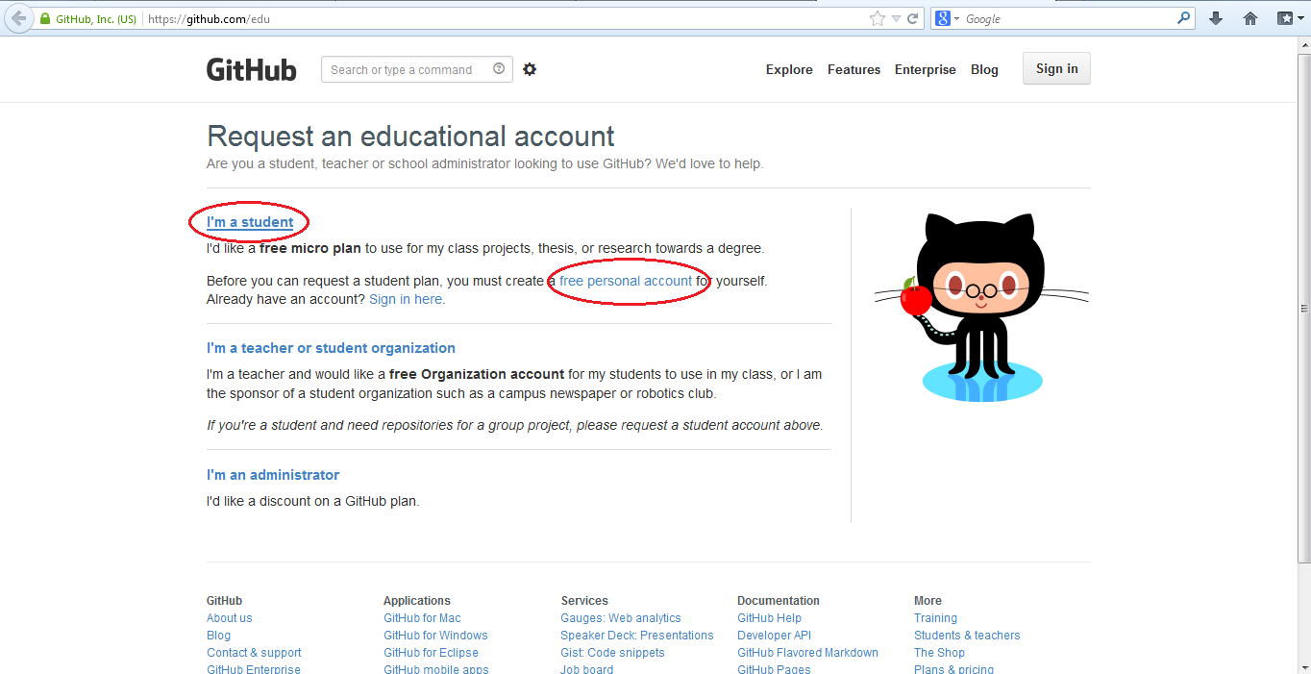

1. Fill out the registration form to create the account.
2. After successful account creation, you’ll be brought to home page. Go back to the <https://github.com/edu> link again and click on the “I’m a student” link again. You’ll find a new form to fill out your school name etc. Fill it up and they’ll tell you that you have to wait some time until they upgrade your account for micro plan. Meanwhile you can browse the different options in Github!
3. Once you get the email that your account has been upgraded go back to your home page. You’ll find a create-new-repo icon one the right side of the navigation bar. Use this to create a new repo.

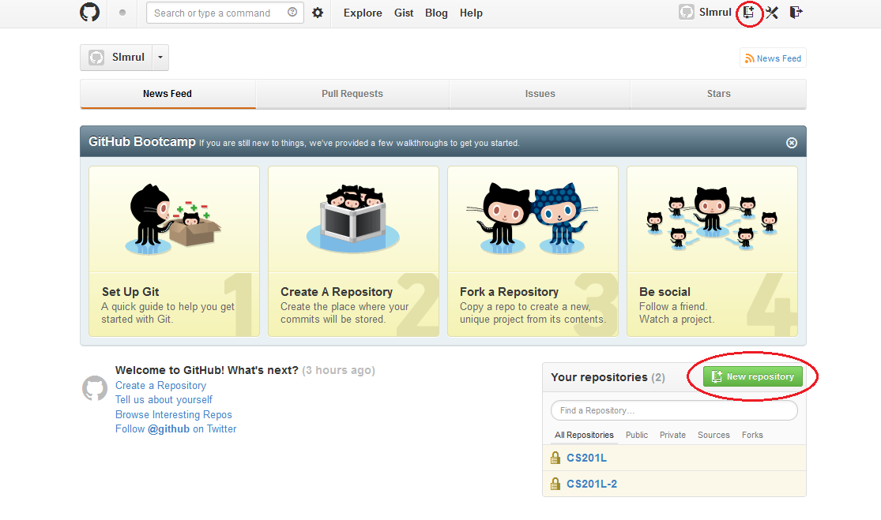

1. Fill up the form as follows:

* Repository Name: CS-201L
* Select “Private”
* Check the "Initialize this repository with a README"

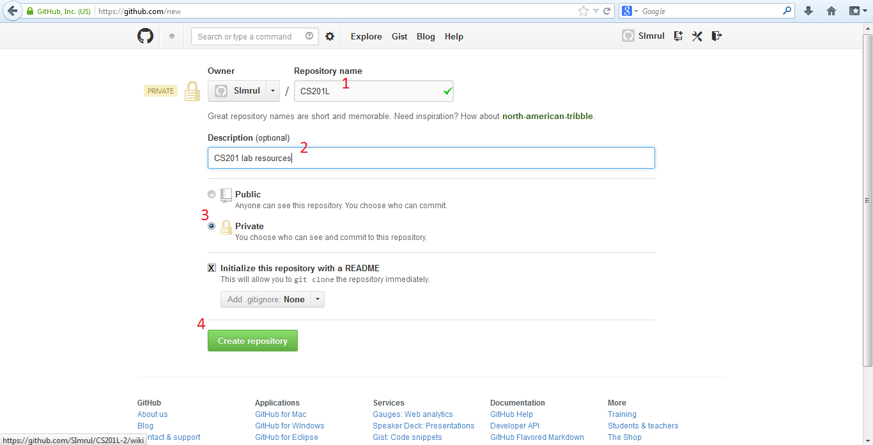

1. You’ll be brought to your repo home page like this following one. Copy the repository location.

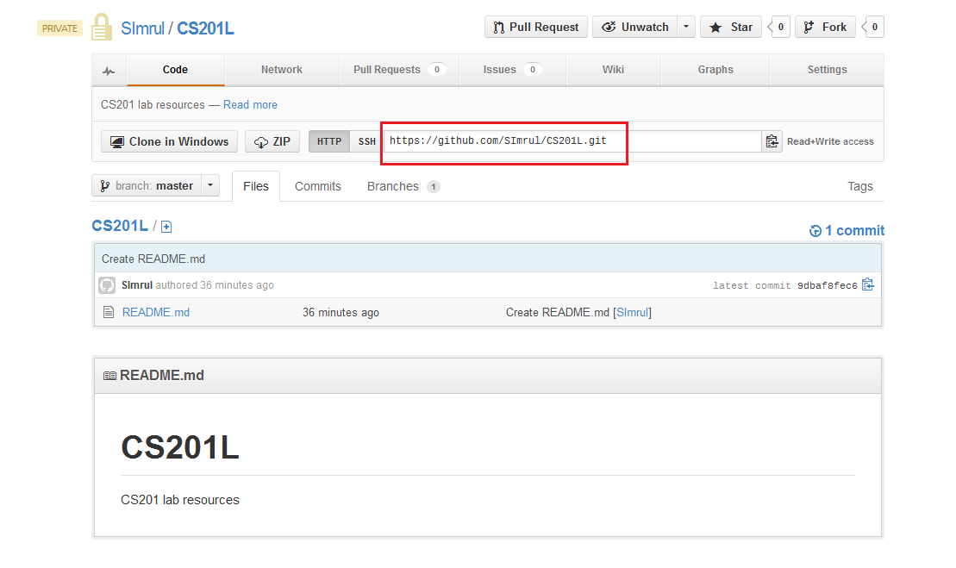

**Cloning the repository**

1. Now go back to your desktop and open “Git Gui” program. Select the “Clone Existing Repository” option.
2. Paste the copied git repository location in the “Source Location” field and provide a target local directory location where the local repo will be created.

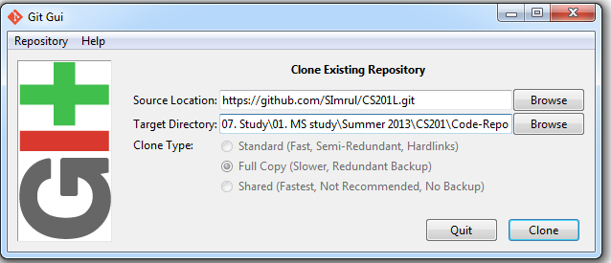

1. Give user-name and password of your git account. It may ask three times, I’m not sure why but do so if asked.
2. If everything is ok, you’ll get a folder with “README.md” file inside and the following Git Gui window:

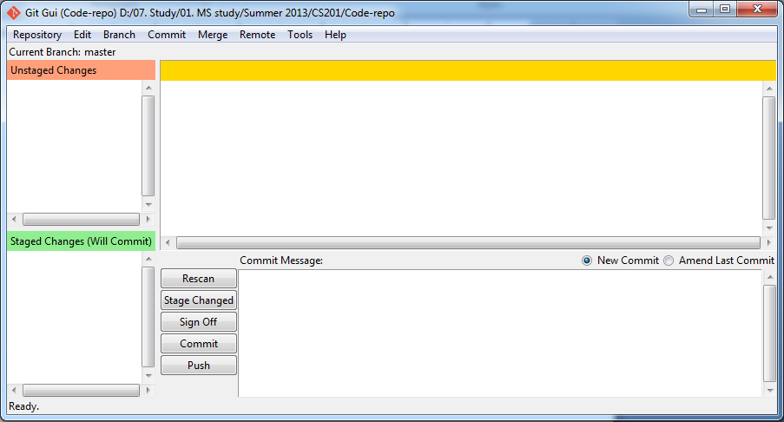

**Committing and Pushing a file:**

1. Now, in your local repo folder, create a new file, for example, test.txt and add some text. Then click the “Rescan” button in the Git program. You’ll see the new file listed in the “Unstaged Changes” section.

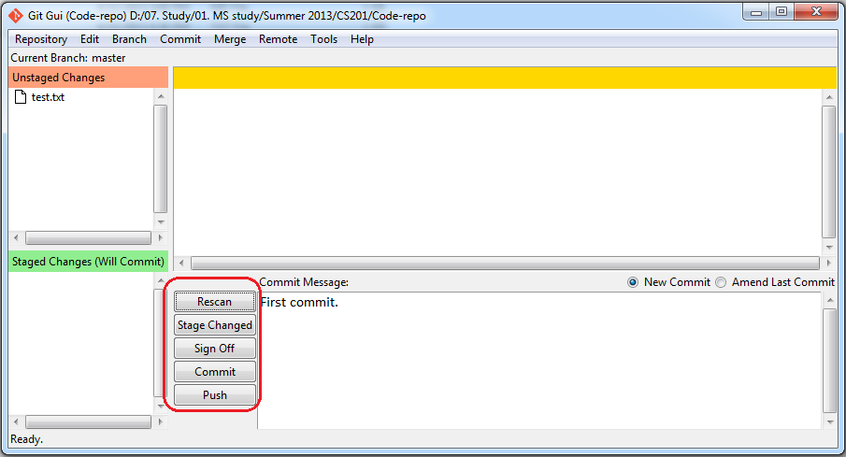

1. Click the “Stage Changed” button to make the changes ready for being committed. You’ll see that the test.txt file is transferred to the “Staged Changes” section.
2. Add some message in the “Commit Message” section and click the Commit button. All your current changes will be committed then. Note that, the commit doesn’t mean the changes will be updated in the remote repository (i.e. your github online repo).
3. To have the changes updated in the remote repo, click the Push button. Keep the default settings on the appeared window and proceed. You’ll be asked for the username and password once more.

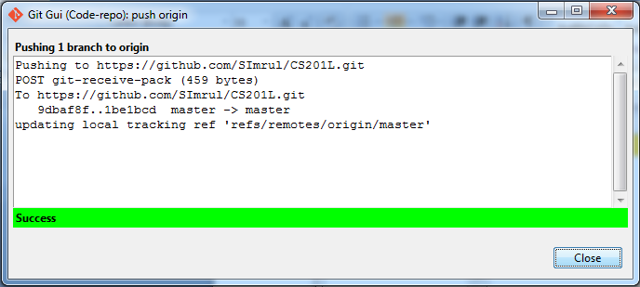

Once done, success message will be shown and in your git remote repo you’ll see the new file is added.

**Sharing with others:**

To share your repo with others that person need to have a Git account. To add someone as collaborator, go to your online git home page. Find the “Repositories” tab on the top middle section. Select the repository and in the repo page, go to settings tab. On the left panel, there should be a “Collaborator” link. You may have to provide your password to view the collaborator section. Add me as a collaborator to your repo, so that in future, we can work together with your codes, if needed. Here’s my id: **SImrul.**

This completes the basic functionalities of Git. There are some more like branching, merging, reverting to a previous commit etc. We won’t cover those in the class as these are more advanced and not within the scope of this class.

**Exit Exercise**

You need to demonstrate the following actions to the lab instructor. Do it yourself at first and see if you can do it all!

1. Create a new Repo naming CS201R (previous one was CS201L).
2. Create a new local copy by cloning from the remote repo.
3. Add two files and push them to remote repo.
4. Delete a file from local copy and push again.
5. Add Rachel as a collaborator of the repo. Her id: **RJMFFF**.